An Investigation into Glance-free Operation of a Touchscreen With and Without Haptic Support in the Driving Simulator

No-visual Operation Driving simulator Tactile feedback

【Influencing factors】：

1. **Touchscreen Position**: [13, 14] show that the ideal position of a touchscreen in the vehicle is directly beside, and at the same height as the steering wheel. A position beneath the steering wheel causes a longer operating duration of more than 10 seconds and longer glances of 4 seconds than a position at the same height as the steering wheel [13, 14].
2. **Touchscreen GUI**: In the GUI design, the size, color selection, and structure of the control elements can play a role in distracting the driver while driving.
3. **Touchscreen Interaction Method**:tap(press/release),swipe,multi-finger gesture (The advantage of the last two operations is that you can use the screen less or less than the first tap. The disadvantage is that it takes more time than the first tap.)
4. **Touchscreen Interaction Task**: Different interactive tasks may take different lengths of time, and input tasks take the longest
5. **Touchscreen Interaction Feedback**
6. **Touchscreen Interaction and Different Road Conditions:** vehicle speed/road surface

【Several Hypothesis】:

H1: Effectiveness is higher during glance-free operation with haptic support than without haptic support.

H2: Efficiency is higher during glance-free operation with haptic support than without haptic support.

H3: The subjective operational stress is lower during glance-free operation with haptic support than without haptic support.

H4: Driving lane deviation is lower during glance-free operation with haptic support than without haptic support.

【Experiments】：

Apparatus：

(1) Console with screen

(2) Device for measuring pressure in the screen (per 5ms)

(3) There are 4 buttons on the screen

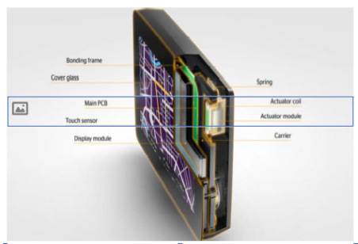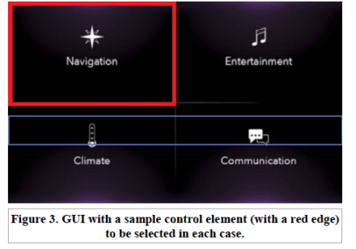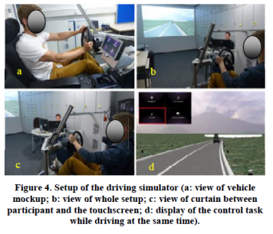

Independent and dependent variables:

interaction modes

effectiveness, efficiency, subjective effort, lane deviation

Experiment Procedure：

1. Introduction with glance.

2. Glance-free interaction without driving (learning).

3. Glance-free interaction with driving.

Questionnaire:

Which is your preferred interaction mode (with or without haptic)?

Do you prefer to have a touchscreen with haptic feedback in your vehicle?

How satisfy are you with the implemented haptic feedback profile?

Results:

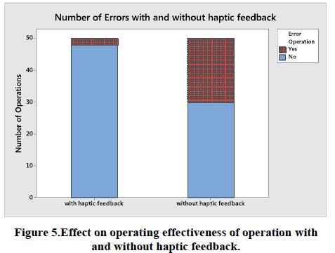 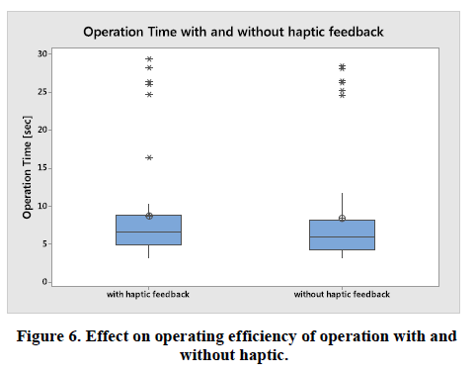

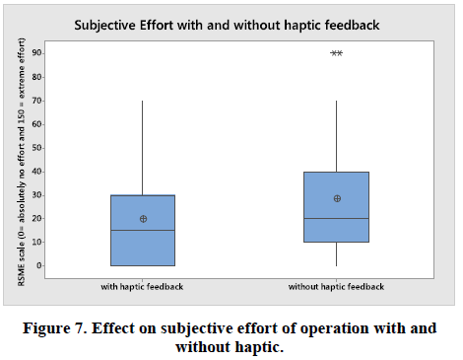 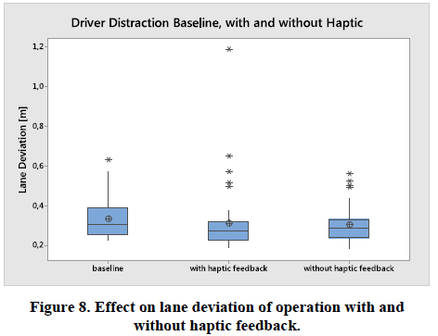

Discuss:

**operating errors:** With haptic feedback is significantly better.

Due to the lack of hand-eye coordination, participants are often too slow to interact with control elements on the touch screen. This means that the system did not detect any attempted inputs. In addition, even if participants can find the correct control element in advance, they often select the wrong option on the touch screen. Participants inadvertently confirmed their choices through short contact with the touch screen while adjusting their orientation, which could lead to a higher error rate.

**lane deviation:** No significant difference between the two modes of interaction.

Analysis of participant feedback showed that all participants liked haptic feedback interactions. Similarly, all participants liked the touch screen with haptic feedback in the vehicle. The main reasons are a higher sense of security and the direction to find the control menu. Most participants are already satisfied with the selected haptic feedback intensity and the resulting auditory feedback. Only five participants felt that the haptic feedback was too strong, so they wanted to use smoother haptic feedback. Some participants proposed having different types of haptic feedback between edge feedback and feedback from selected control elements.

【Important Reference】:

BMW. Instrumentation and Controls.2018. Retrieved May 2, 2018 from <https://www.bmwusa.com/vehicles/7-series/pricing-features.html>

Catherine Harvey, Neville A. Stanton, Carl A. Pickering, Mike McDonald, and Pengjun Zheng Jofish. 2011. To twist or poke? A method for identifying usability issues with the rotary controller and touch screen for control of in-vehicle information systems.

Seongkook Heo and Geehyuk Lee. 2011. Forcetap: extending the input vocabulary of mobile touch screens by adding tap gestures. In Proceedings of the 13th International Conference on Human Computer Interaction with Mobile Devices and Services,(MobileHCI '11), 113-122.http://doi.acm.org/10.1145/2037373.2037393

Tuomo Kujala. 2012. Browsing the information highway while driving: three in-vehicle touch screen scrolling methods and driver distraction. Personal and ubiquitous computing. 17, 5 (April 2012), 815-823. https://doi.org/10.1007/s00779-012-0517-2